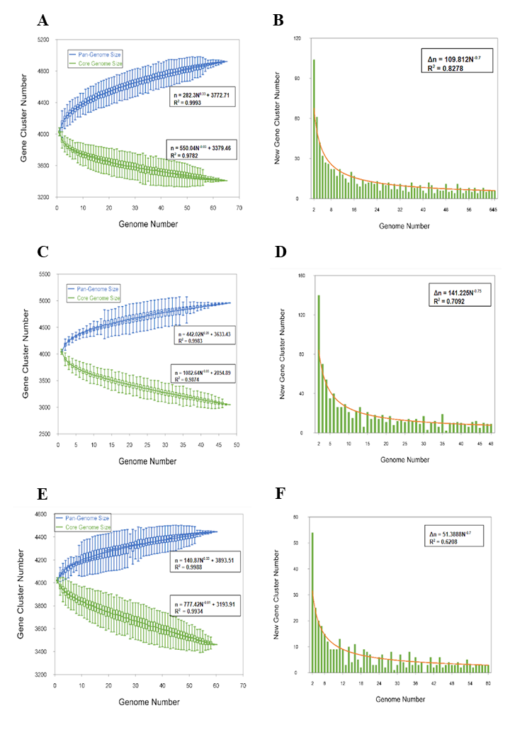
Supplementary figure 2 Pan-genome curve and new gene accumulation curve of MDR-TB isolates from (A, B) Arunachal Pradesh, (C, D) Odisha, (E, F) Sikkim

